 | Experiment Title: Implement data pre-processing.
 | Laboratory: MACHINE LEARNING LAB
Experiment No: 1 | Department | Semester:

Data Preprocessing in Machine learning
Data preprocessing is a process of preparing the raw data and making it suitable for a machine learning model. It is the first and crucial step while creating a machine learning model.
When creating a machine learning project, it is not always a case that we come across the clean and formatted data. And while doing any operation with data, it is mandatory to clean it and put in a formatted way. So for this, we use data preprocessing task.


Figure 1 Data Preprocessing

Why do we need Data Preprocessing?
A real-world data generally contains noises, missing values, and maybe in an unusable format which cannot be directly used for machine learning models. Data preprocessing is required tasks for cleaning the data and making it suitable for a machine learning model which also increases the accuracy and efficiency of a machine learning model.
It involves below steps:
- Getting the dataset
- Importing libraries
- Importing datasets
- Finding Missing Data
- Encoding Categorical Data
- Splitting dataset into training and test set
- Feature scaling

Performing Data Preprocessing:
Get the Dataset: To create a machine learning model, the first thing we required is a dataset as a machine learning model completely works on data. The collected data for a particular problem in a proper format is known as the dataset. To use the dataset in our code, we usually put it into a CSV file. CSV stands for "Comma-Separated Values" files. Here dataset we have used is diabetes.csv.

Importing Libraries: In order to perform data preprocessing using Python, we need to import some predefined Python libraries. These libraries are used to perform some specific jobs. There are three specific libraries that we will use for data preprocessing, which are: numpy, pandas, matplotlib.

Importing the Datasets: Now we need to import the datasets which we have collected for our machine learning project. But before importing a dataset, we need to set the current directory as a working directory.

Handling Missing data: The next step of data preprocessing is to handle missing data in the datasets. If our dataset contains some missing data, then it may create a huge problem for our machine learning model. Hence it is necessary to handle missing values present in the dataset.
Ways to handle missing data:
There are mainly two ways to handle missing data, which are:
- By deleting the particular row: The first way is used to commonly deal with null values. In this way, we just delete the specific row or column which consists of null values. But this way is not so efficient and removing data may lead to loss of information which will not give the accurate output.
- By calculating the mean: In this way, we will calculate the mean of that column or row which contains any missing value and will put it on the place of missing value. This strategy is useful for the features which have numeric data such as age, salary, year, etc. Here, we will use this approach.
To handle missing values, we will use Scikit-learn library in our code, which contains various libraries for building machine learning models. Here we will use Imputer class of sklearn.preprocessing library.
Encoding Categorical Data: Since machine learning model completely works on mathematics and numbers, but if our dataset would have a categorical variable, then it may create trouble while building the model. So it is necessary to encode these categorical variables into numbers.
Splitting dataset into training and test set: In machine learning data preprocessing, we divide our dataset into a training set and test set. This is one of the crucial steps of data preprocessing as by doing this, we can enhance the performance of our machine learning model.
- Training Set: A subset of dataset to train the machine learning model, and we already know the output.
- Test set: A subset of dataset to test the machine learning model, and by using the test set, model predicts the output.
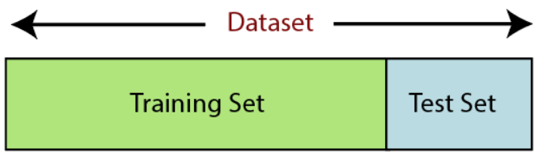
Figure 2 Train and Test
Feature Scaling: Feature scaling is the final step of data preprocessing in machine learning. It is a technique to standardize the independent variables of the dataset in a specific range. In feature scaling, we put our variables in the same range and in the same scale so that no any variable dominate the other variable. There are two ways to perform feature scaling in machine learning:
Standardization and Normalization
Here, we will use the standardization method for our dataset.
Standardization Normalization 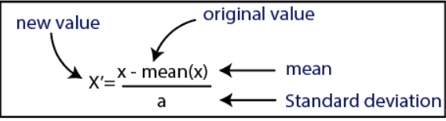 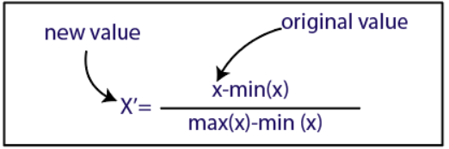
Figure 3 Feature Scaling
PROGRAM

# importing libraries
import numpy as np
import pandas as pd
from sklearn.impute import SimpleImputer
from sklearn.preprocessing import LabelEncoder, OneHotEncoder
from sklearn.compose import ColumnTransformer
from sklearn.model_selection import train_test_split
from sklearn.preprocessing import StandardScaler
#importing datasets
dataset = pd.read_csv('Real-estate1.csv')
print(dataset.head())

OUTPUT
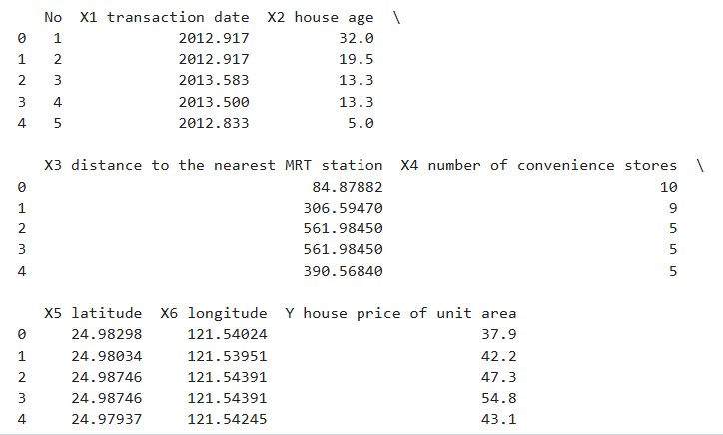

#Extracting Independent Variable
x= data_set.iloc[:, :-1].values
#Extracting Dependent variable
y= data_set.iloc[:, 3].values
#Printing the extracted values
print(x)
print(y)

OUTPUT
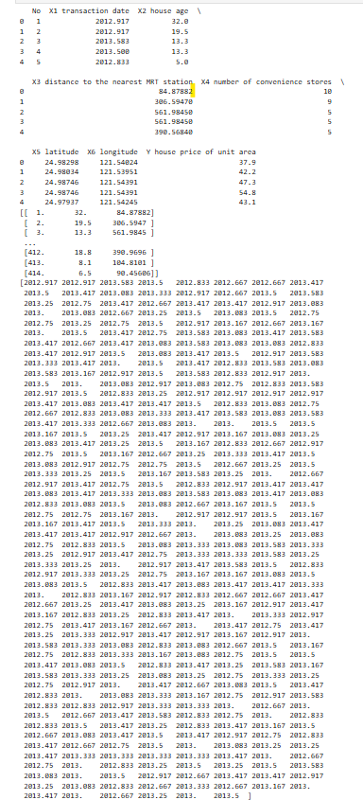

# Handling missing data (Replacing missing data with the mean value)
imp = SimpleImputer(missing_values=np.nan, strategy='mean')
X = imp.fit_transform(X)
Y = Y.reshape(-1, 1)
Y = imp.fit_transform(Y)
Y = Y.reshape(-1)
# Encoding categorical data using LabelEncoder and ColumnTransformer
le_X = LabelEncoder()
X[:, 0] = le_X.fit_transform(X[:, 0])
# Using ColumnTransformer to OneHotEncode the first column
column_transformer = ColumnTransformer(transformers=[('onehot', OneHotEncoder(), [0]) # Apply OneHotEncoder to column index 0],
\ remainder='passthrough' # Keep the rest of the columns unchanged
)
X = column_transformer.fit_transform(X)
# Splitting the dataset into training and testing sets
X_train, X_test, Y_train, Y_test = train_test_split(X, Y, test_size=0.2, random_state=0)
# Feature scaling using StandardScaler (with_mean=False for sparse data)
scaler = StandardScaler(with_mean=False)
X_train = scaler.fit_transform(X_train)
X_test = scaler.transform(X_test)
# Display final transformed data
print("X (after transformations):", X)
print("Y:", Y)
OUTPUT
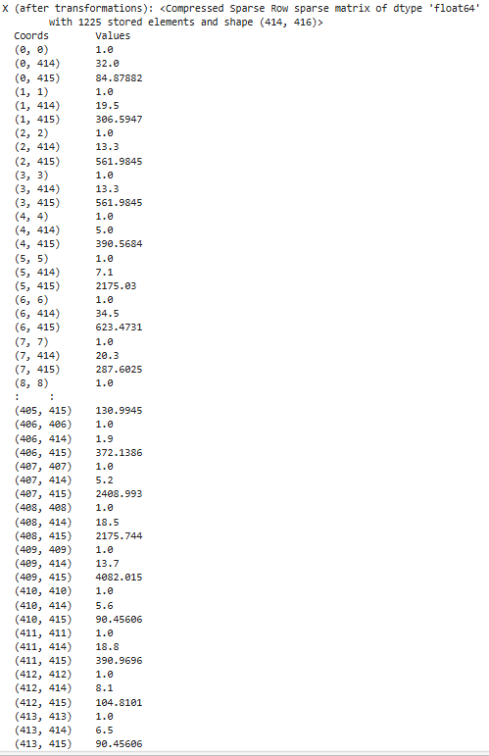

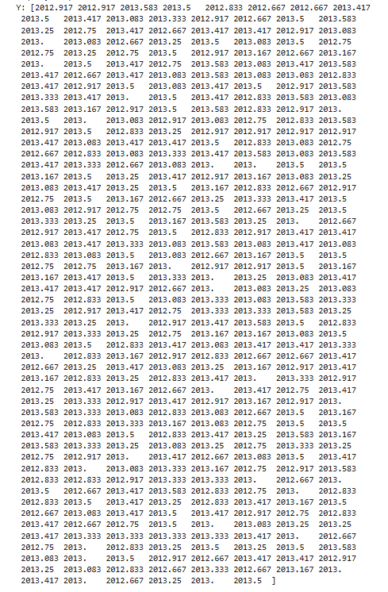

 | Experiment Title: Deploy Simple Linear Regression.
 | Laboratory: MACHINE LEARNING LAB
Experiment No: 2 | Department | Semester:

PROGRAM
import numpy as np
import matplotlib.pyplot as plt
import pandas as pd
from sklearn.model_selection import train_test_split
from sklearn.linear_model import LinearRegression
from sklearn import metrics

# Load the dataset
dataset = pd.read_csv('diabetes.csv') # Replace with the correct path if needed
x = dataset.iloc[:, :-1].values
y = dataset.iloc[:, -1].values

# Split the dataset into training and test sets
x_train, x_test, y_train, y_test = train_test_split(x, y, test_size=1/3, random_state=0)

# Train the linear regression model
reg = LinearRegression()
reg.fit(x_train, y_train)

# Predict the training and test set results
y_train_predict = reg.predict(x_train)
y_test_predict = reg.predict(x_test)

# Plot the training set results
plt.scatter(x_train[:, 0], y_train, color='red') # Plotting with the first feature for simplicity
plt.plot(x_train[:, 0], y_train_predict, color='blue')
plt.title('Diabetes Progression (Training set)')
plt.xlabel('Feature 0')
plt.ylabel('Target')
plt.show()

# Plot the test set results
plt.scatter(x_test[:, 0], y_test, color='red') # Plotting with the first feature for simplicity
plt.plot(x_test[:, 0], y_test_predict, color='blue')
plt.title('Diabetes Progression (Test set)')
plt.xlabel('Feature 0')
plt.ylabel('Target')
plt.show()
OUTPUT:

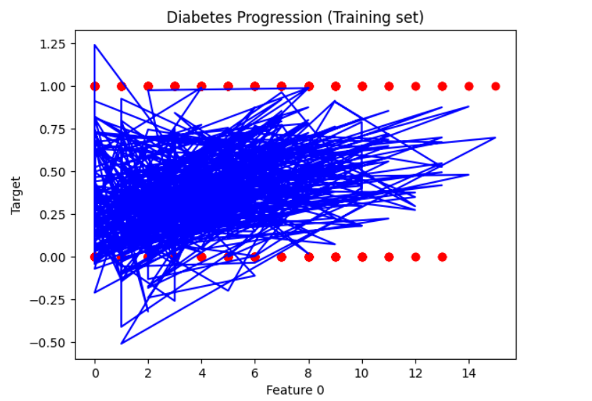

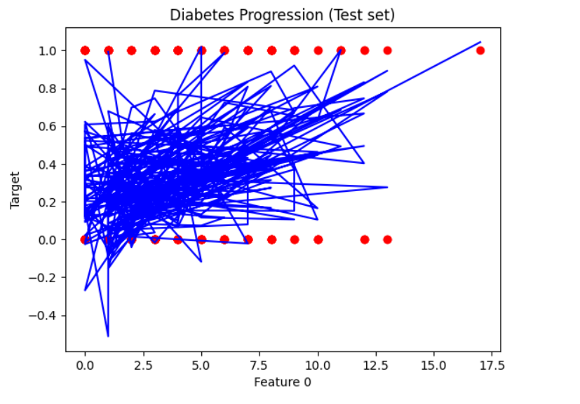

 | Experiment Title: Simulate Multiple Linear Regression.
 | Laboratory: MACHINE LEARNING LAB
Experiment No: 3 | Department | Semester:

PROGRAM

# importing modules and packages
import pandas as pd
import numpy as np
import matplotlib.pyplot as plt
import seaborn as sns
from sklearn.model_selection import train_test_split
from sklearn.linear_model import LinearRegression
from sklearn.metrics import mean_squared_error, mean_absolute_error
from sklearn import preprocessing

# importing data
df = pd.read_csv('Real-estate1.csv')
df.drop('No', inplace=True, axis=1)
print(df.head())
print(df.columns)

# plotting a scatterplot
sns.scatterplot(x='X4 number of convenience stores', y='Y house price of unit area', data=df)
# creating feature variables
X = df.drop('Y house price of unit area', axis=1)
y = df['Y house price of unit area']
print(X)
print(y)

# creating train and test sets
X_train, X_test, y_train, y_test = train_test_split( X, y, test_size=0.3, random_state=101)

# creating a regression model
model = LinearRegression()

# fitting the model
model.fit(X_train, y_train)

# making predictions
predictions = model.predict(X_test)
# model evaluation
print('mean_squared_error : ', mean_squared_error(y_test, predictions))
print('mean_absolute_error : ', mean_absolute_error(y_test, predictions))

OUTPUT

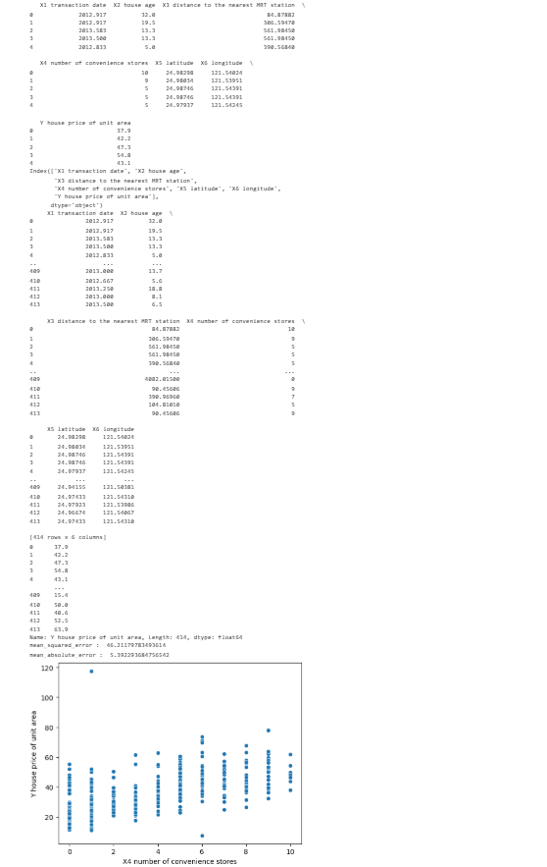

 | Experiment Title: Implement Decision Tree.
 | Laboratory: MACHINE LEARNING LAB
Experiment No: 4 | Department | Semester:

Decision Tree
A Decision tree is a tree-like structure that represents a set of decisions and their possible consequences. Each node in the tree represents a decision, and each branch represents an outcome of that decision. The leaves of the tree represent the final decisions or predictions.
Decision trees are created by recursively partitioning the data into smaller and smaller subsets. At each partition, the data is split based on a specific feature, and the split is made in a way that maximizes the information gain. The Decision Tree algorithm works by selecting the best feature to split the data at each node. The best feature is the one that provides the most information gain or the most reduction in entropy. Information gain is a measure of the amount of information gained by splitting the data at a particular feature, while entropy is a measure of the randomness or disorder in the data. The algorithm uses these measures to determine the best feature to split the data at each node.
The example of a binary tree for predicting whether a person is fit or unfit providing various information like age, eating habits and exercise habits, is given below –
In the below decision tree, the question are decision nodes and final outcomes are leaves.
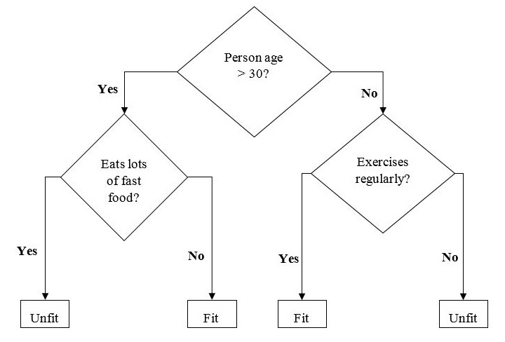
Figure 1 Decision Tree

Types of Decision Tree Algorithm
There are two main types of Decision Tree algorithm –

Classification Tree − A classification tree is used to classify data into different classes or categories. It works by splitting the data into subsets based on the values of the input features and assigning each subset to a different class.
Regression Tree − A regression tree is used to predict numerical values or continuous variables. It works by splitting the data into subsets based on the values of the input features and assigning each subset a numerical value.

PROGRAM
#import libraries
import numpy as np
from sklearn.datasets import load_iris
from sklearn.model_selection import train_test_split
from sklearn.tree import DecisionTreeClassifier
# Load the iris dataset
iris = load_iris()
# Split the dataset into training and testing sets
X_train, X_test, y_train, y_test = train_test_split(iris.data, iris.target, test_size=0.3, random_state=0)
# Create a Decision Tree classifier
dtc = DecisionTreeClassifier()
# Fit the classifier to the training data
dtc.fit(X_train, y_train)
# Make predictions on the testing data
y_pred = dtc.predict(X_test)
# Calculate the accuracy of the classifier
accuracy = np.sum(y_pred == y_test) / len(y_test)
print("Accuracy:", accuracy)
# Visualize the Decision Tree using Matplotlib
import matplotlib.pyplot as plt
from sklearn.tree import plot_tree
plt.figure(figsize=(20,10))
plot_tree(dtc, filled=True, feature_names=iris.feature_names,
class_names=iris.target_names)
plt.show()

OUTPUT

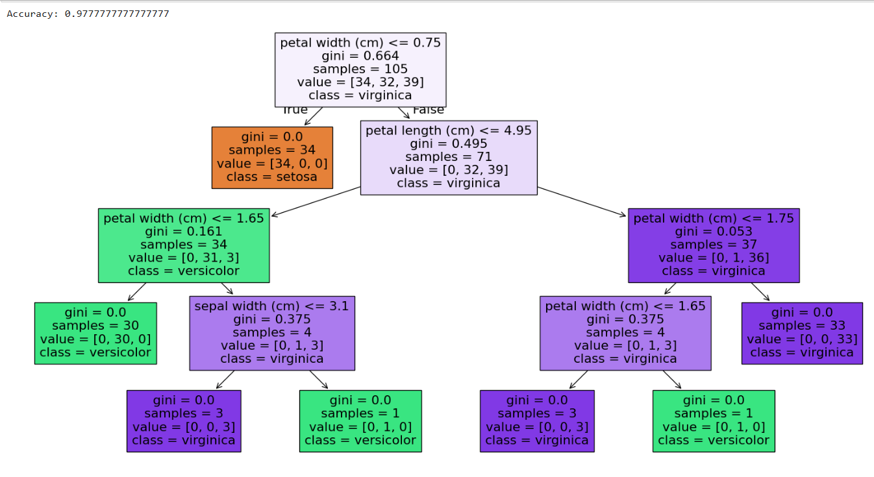

 | Experiment Title: Deploy Random forest classification.
 | Laboratory: MACHINE LEARNING LAB
Experiment No: 5 | Department | Semester:

Random Forest
The Random forest or Random Decision Forest is a supervised Machine learning algorithm used for classification, regression, and other tasks using decision trees. Random Forests are particularly well-suited for handling large and complex datasets, dealing with high-dimensional feature spaces, and providing insights into feature importance. This algorithm’s ability to maintain high predictive accuracy while minimizing overfitting makes it a popular choice across various domains, including finance, healthcare, and image analysis, among others.

Random Forest Classifier
The Random forest classifier creates a set of decision trees from a randomly selected subset of the training set. It is a set of decision trees (DT) from a randomly selected subset of the training set and then It collects the votes from different decision trees to decide the final prediction.
Additionally, the random forest classifier can handle both classification and regression tasks, and its ability to provide feature importance scores makes it a valuable tool for understanding the significance of different variables in the dataset.

Imagine asking a group of friends for advice on where to go for vacation. Each friend gives their recommendation based on their unique perspective and preferences (decision trees trained on different subsets of data). You then make your final decision by considering the majority opinion or averaging their suggestions (ensemble prediction).
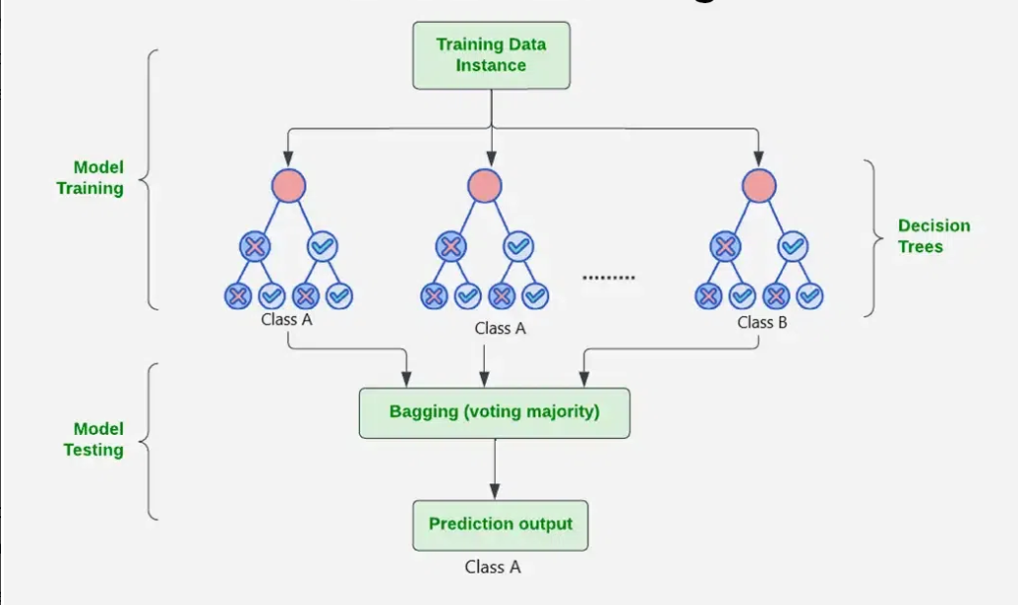
Figure 2 Random Forest Classification
PROGRAM

import pandas as pd
from sklearn import datasets
from sklearn.model_selection import train_test_split
from sklearn.ensemble import RandomForestClassifier
from sklearn.metrics import accuracy_score, classification_report

# Load the dataset
iris = datasets.load_iris()
X, y = datasets.load_iris(return_X_y=True)
# Split the dataset into training and testing sets
X_train, X_test, y_train, y_test = train_test_split(X, y, test_size=0.30, random_state=42)
# Create a Random Forest Classifier
clf = RandomForestClassifier(n_estimators=100, random_state=42)

# Train the classifier
clf.fit(X_train, y_train)
# Make predictions on the test set
y_pred = clf.predict(X_test)

# Evaluate the model
accuracy = accuracy_score(y_test, y_pred)
classification_rep = classification_report(y_test, y_pred)

# Print the results
print(f"Accuracy: {accuracy:.2f}")
print("\nClassification Report:\n", classification_rep)

OUTPUT
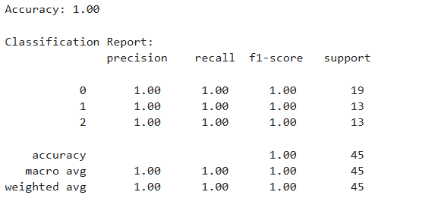

 | Experiment Title: Simulate Naïve Bayes algorithm.
 | Laboratory: MACHINE LEARNING LAB
Experiment No: 6 | Department | Semester:

Naive Bayes Algorithm in Machine Learning
Naive Bayes classifiers are supervised machine learning algorithms used for classification tasks, based on Bayes’ Theorem to find probabilities. It is a simple yet powerful algorithm because of its understanding, simplicity and ease of implementation. It is popular method for classification applications such as spam filtering and text classification. It is named as “Naive” because it assumes the presence of one feature does not affect other features. The “Bayes” part of the name refers to the basis in Bayes’ Theorem.

Key Features of Naive Bayes Classifiers
The main idea behind the Naive Bayes classifier is to use Bayes’ Theorem to classify data based on the probabilities of different classes given the features of the data. It is used mostly in high-dimensional text classification
- The Naive Bayes Classifier is a simple probabilistic classifier and it has very few number of parameters which are used to build the ML models that can predict at a faster speed than other classification algorithms.
- It is a probabilistic classifier because it assumes that one feature in the model is independent of existence of another feature. In other words, each feature contributes to the predictions with no relation between each other.
- Naïve Bayes Algorithm is used in spam filtration, Sentimental analysis, classifying articles and many more.
Bayes’ theorem is stated mathematically as the following equation:
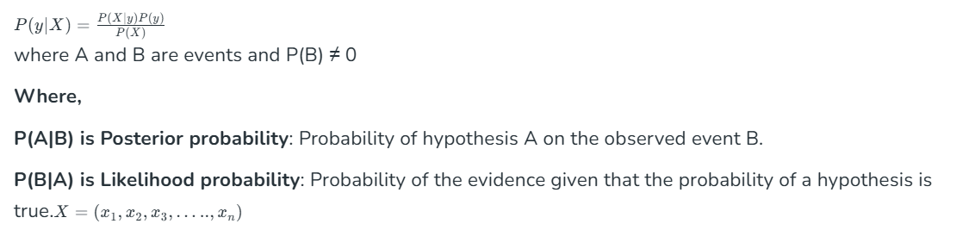

Applications of Naive Bayes Classifier
- Spam Email Filtering: Classifies emails as spam or non-spam based on features.
- Text Classification: Used in sentiment analysis, document categorization, and topic classification.
- Medical Diagnosis: Helps in predicting the likelihood of a disease based on symptoms.
- Credit Scoring: Evaluates creditworthiness of individuals for loan approval.
- Weather Prediction: Classifies weather conditions based on various factors.

PROGRAM
# import necessary libraries
import pandas as pd
from sklearn import tree
from sklearn.preprocessing import LabelEncoder
from sklearn.naive_bayes import GaussianNB
# Load Data from CSV
data = pd.read_csv('tennis.csv')
print("The first 5 Values of data is :\n", data.head())

OUTPUT
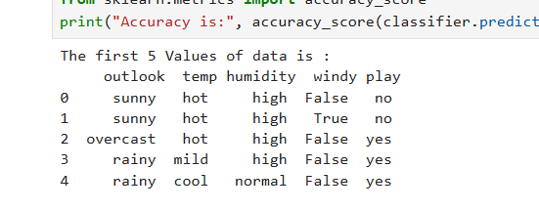
# obtain train data and train output
X = data.iloc[:, :-1]
print("\nThe First 5 values of the train data is\n", X.head())
y = data.iloc[:, -1]
print("\nThe First 5 values of train output is\n", y.head())

OUTPUT
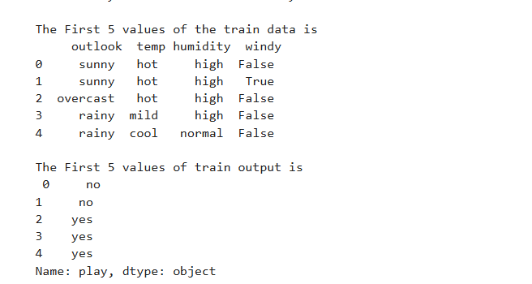
# convert them in numbers
le_outlook = LabelEncoder()
X.outlook = le_outlook.fit_transform(X.outlook)
le_temp = LabelEncoder()
X.temp = le_temp.fit_transform(X.temp)
le_humidity = LabelEncoder()
X.humidity = le_humidity.fit_transform(X.humidity)
le_windy = LabelEncoder()
X.windy = le_windy.fit_transform(X.windy)
print("\nNow the Train output is\n", X.head())
le_PlayTennis = LabelEncoder()
y = le_PlayTennis.fit_transform(y)
print("\nNow the Train output is\n",y)
from sklearn.model_selection import train_test_split
X_train, X_test, y_train, y_test = train_test_split(X,y, test_size = 0.20)
classifier = GaussianNB()
classifier.fit(X_train, y_train)
from sklearn.metrics import accuracy_score
print("Accuracy is:", accuracy_score(classifier.predict(X_test), y_test))

OUTPUT
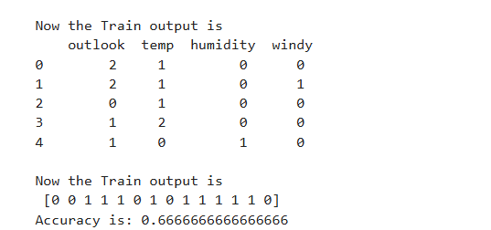

 | Experiment Title: Implement K-Nearest Neighbors (K-NN), k-Means.
 | Laboratory: MACHINE LEARNING LAB
Experiment No: 7 | Department | Semester:

K-nearest neighbors (KNN)

KNN is a simple, supervised machine learning (ML) algorithm that can be used for classification or regression tasks - and is also frequently used in missing value imputation. It is based on the idea that the observations closest to a given data point are the most "similar" observations in a data set, and we can therefore classify unforeseen points based on the values of the closest existing points. By choosing K, the user can select the number of nearby observations to use in the algorithm.
How Does K-Nearest Neighbors Algorithm Work
K-nearest neighbors (KNN) algorithm uses 'feature similarity' to predict the values of new data points which further means that the new data point will be assigned a value based on how closely it matches the points in the training set. We can understand its working with the help of following steps −
Step 1 − For implementing any algorithm, we need dataset. So during the first step of KNN, we must load the training as well as test data.
Step 2 − Next, we need to choose the value of K i.e. the nearest data points. K can be any integer.
Step 3 − For each point in the test data do the following −
3.1 − Calculate the distance between test data and each row of training data with the help of any of the method namely: Euclidean, Manhattan or Hamming distance. The most commonly used method to calculate distance is Euclidean.
3.2 − Now, based on the distance value, sort them in ascending order.
3.3 − Next, it will choose the top K rows from the sorted array.
3.4 − Now, it will assign a class to the test point based on most frequent class of these rows.
Step 4 − End

PROGRAM
# Import necessary libraries
import pandas as pd
import matplotlib.pyplot as plt
from sklearn.neighbors import KNeighborsClassifier
from sklearn.model_selection import train_test_split
from sklearn.inspection import DecisionBoundaryDisplay
from sklearn.metrics import accuracy_score

# Load Data from CSV
data = pd.read_csv('tennis.csv')
print("The first 5 values of the dataset are:\n", data.head())

# Prepare train data and train output
X = data.iloc[:, :-1]
y = data.iloc[:, -1]
# Convert categorical features to numerical values
X = X.apply(LabelEncoder().fit_transform)
y = LabelEncoder().fit_transform(y)

# Split the dataset into training and testing sets
X_train, X_test, y_train, y_test = train_test_split(X, y, test_size=0.20)

# Train K-NN
k = 3 # Number of neighbors
knn = KNeighborsClassifier(n_neighbors=k)
knn.fit(X_train, y_train)

# Predict and calculate accuracy
y_pred_knn = knn.predict(X_test)
accuracy_knn = accuracy_score(y_test, y_pred_knn)
print("Accuracy with K-NN (k=3):", accuracy_knn)

# Create a table showing actual and predicted values
results_table = pd.DataFrame({'Actual': y_test, 'Predicted': y_pred_knn})
print("\nResults Table:")
print(results_table)

# Visualize decision boundaries (using only two features for visualization)
X_subset = X.iloc[:, :2] # Select first two features for visualization
knn_decision = KNeighborsClassifier(n_neighbors=k)
knn_decision.fit(X_subset, y)
DecisionBoundaryDisplay.from_estimator(
knn_decision,
X_subset,
response_method="predict",
cmap=plt.cm.Spectral,
alpha=0.8,
xlabel=data.columns[0],
ylabel=data.columns[1],
)
# Scatter plot of data points
plt.scatter(X_subset.iloc[:, 0], X_subset.iloc[:, 1], c=y, s=20, edgecolors="k")
plt.title("Decision Boundary Visualization (K-NN)")
plt.show()

OUTPUT

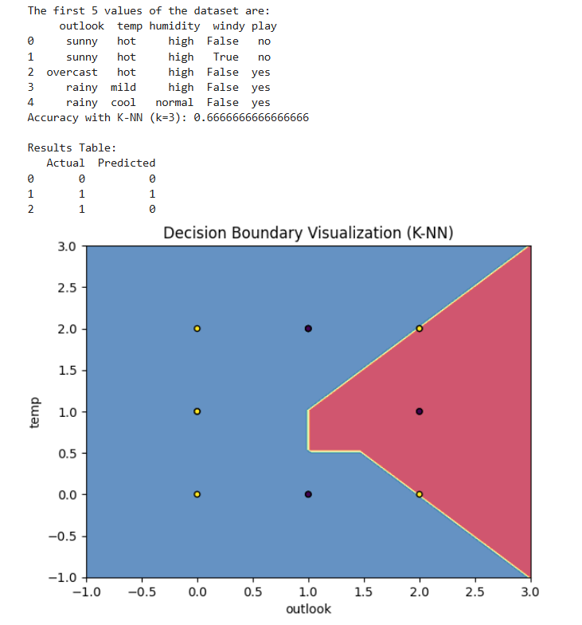

K-means Algorithm

K-means is an unsupervised learning method for clustering data points. The algorithm iteratively divides data points into K clusters by minimizing the variance in each cluster. The algorithm works by first randomly picking some central points called centroids and each data point is then assigned to the closest centroid forming a cluster. After all the points are assigned to a cluster the centroids are updated by finding the average position of the points in each cluster. This process repeats until the centroids stop changing forming clusters. The goal of clustering is to divide the data points into clusters so that similar data points belong to same group.

Working of K-Means Algorithm
The following stages will help us understand how the K-Means clustering technique works-
- Step 1: First, we need to provide the number of clusters k , that need to be generated by this algorithm.
- Step 2: Next, choose K data points at random and assign each to a cluster. Briefly, categorize the data based on the number of data points.
- Step 3: The computation of initial cluster centroids will now be performed.
- Step 4: Iterate the steps below until we find the ideal centroid, which is the assigning of data points to the closest cluster centroids, ensuring minimal variance within each cluster.
  - 4.1 The sum of squared distances between data points and initial centroids would be calculated first.
  - 4.2 At this point, we need to allocate each data point to the cluster that is closest to the others nearest centroid.
  - 4.3 Finally, compute the closest centroids for the clusters by averaging all of the cluster’s data points.
K-means implements the Expectation-Maximization strategy to solve the problem. The Expectation-step is used to assign data points to the nearest cluster, and the Maximization-step is used to compute the centroid of each cluster.

PROGRAM
# Import necessary libraries
import pandas as pd
import matplotlib.pyplot as plt
from sklearn.cluster import KMeans
from sklearn.preprocessing import LabelEncoder

# Load Data from CSV
data = pd.read_csv('tennis.csv')
print("The first 5 values of the dataset are:\n", data.head())

# Prepare input data
X = data.iloc[:, :-1]

# Convert categorical features to numerical values
X = X.apply(LabelEncoder().fit_transform)

# K-Means Clustering
k = 3 # Number of clusters
kmeans = KMeans(n_clusters=k, random_state=42)
kmeans.fit(X)

# Predict cluster labels
cluster_labels = kmeans.predict(X)
print("\nCluster Labels:", cluster_labels)

# Add cluster labels to the original dataset for analysis
data['Cluster'] = cluster_labels
print("\nDataset with Cluster Labels:")
print(data)

# Visualize Clusters (using first two features for visualization)
plt.scatter(X.iloc[:, 0], X.iloc[:, 1], c=cluster_labels, cmap=plt.cm.Spectral, s=20)
plt.title("K-Means Clustering Visualization")
plt.xlabel(data.columns[0])
plt.ylabel(data.columns[1])
plt.show()

OUTPUT
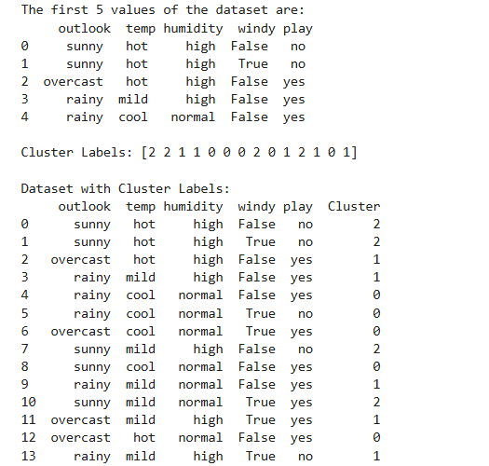
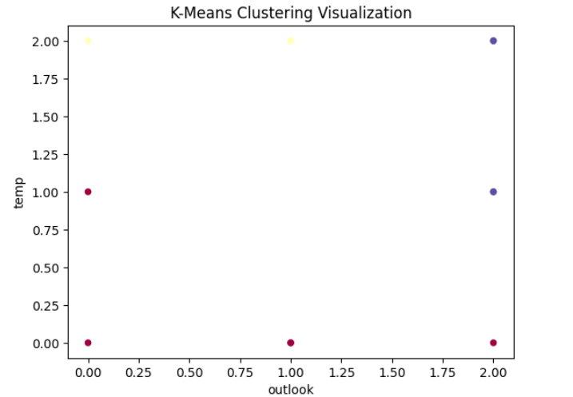

 | Experiment Title: Deploy Support Vector Machine, Apriori algorithm.
 | Laboratory: MACHINE LEARNING LAB
Experiment No: 8 | Department | Semester:

Support Vector Machine (SVM)
Support vector machines (SVMs) are powerful yet flexible supervised machine learning algorithm which is used for both classification and regression. But generally, they are used in classification problems. In 1960s, SVMs were first introduced but later they got refined in 1990 also. SVMs have their unique way of implementation as compared to other machine learning algorithms. Now days, they are extremely popular because of their ability to handle multiple continuous and categorical variables.

Terminology
Hyperplane: A hyperplane aka decision boundary/surface is an n-dimensional Euclidean space that distinctly separates the data points. The data points on either side of the hyperplane belong to different classes. If we have a p-dimensional feature set, the dimension of the hyperplane will be p-1.
Support Vectors: The individual data points that are close to the hyperplane are called the support vectors.
Margin: The width that the boundary could be increased before hitting a data point. In simple terms, the distance between the hyperplane and the support vectors is referred to as the Margin.

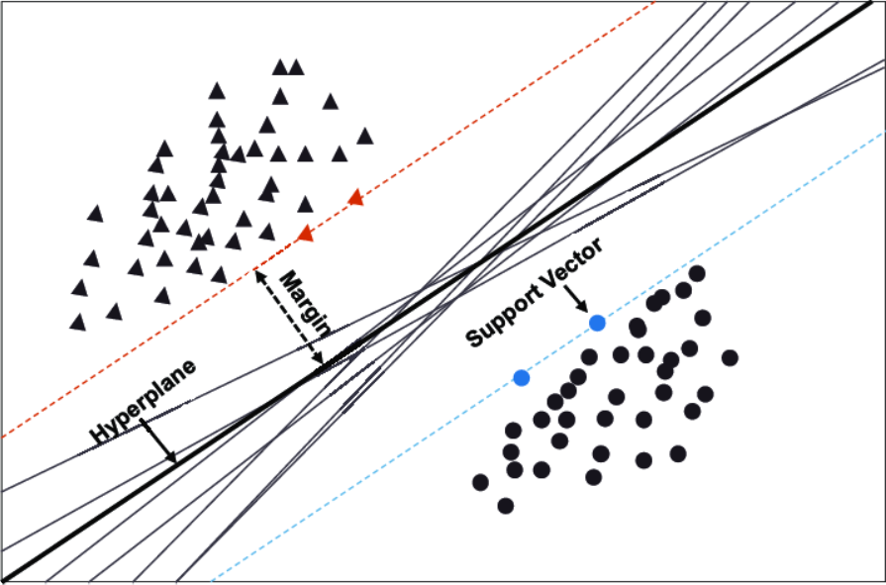
Figure 1 Illustrating Hyperplanes, Support Vectors, and Margin

Pros and Cons of SVM Classifiers
Pros of SVM classifiers
SVM classifiers offers great accuracy and work well with high dimensional space. SVM classifiers basically use a subset of training points hence in result uses very less memory.
Cons of SVM classifiers
They have high training time hence in practice not suitable for large datasets. Another disadvantage is that SVM classifiers do not work well with overlapping classes.

PROGRAM
# Import necessary libraries
import pandas as pd
import matplotlib.pyplot as plt
from sklearn.svm import SVC
from sklearn.preprocessing import LabelEncoder
from sklearn.model_selection import train_test_split
from sklearn.inspection import DecisionBoundaryDisplay
from sklearn.metrics import accuracy_score

# Load Data from CSV
data = pd.read_csv('tennis.csv')
print("The first 5 values of the dataset are:\n", data.head())

# Obtain train data and train output
X = data.iloc[:, :-1]
y = data.iloc[:, -1]
print("\nThe first 5 values of the training data are:\n", X.head())
print("\nThe first 5 values of the training output are:\n", y.head())

# Convert categorical features into numerical values
le_outlook = LabelEncoder()
X['outlook'] = le_outlook.fit_transform(X['outlook'])
le_temp = LabelEncoder()
X['temp'] = le_temp.fit_transform(X['temp'])
le_humidity = LabelEncoder()
X['humidity'] = le_humidity.fit_transform(X['humidity'])
le_windy = LabelEncoder()
X['windy'] = le_windy.fit_transform(X['windy'])
print("\nThe transformed training data is:\n", X.head())

le_PlayTennis = LabelEncoder()
y = le_PlayTennis.fit_transform(y)
print("\nThe transformed training output is:\n", y)

# Split the dataset into training and testing sets
X_train, X_test, y_train, y_test = train_test_split(X, y, test_size=0.20)

# Instantiate and train the SVM classifier with linear kernel
svm_linear = SVC(kernel='linear')
svm_linear.fit(X_train, y_train)

# Predict and calculate accuracy for linear kernel
y_pred_linear = svm_linear.predict(X_test)
print("Accuracy with linear kernel:", accuracy_score(y_test, y_pred_linear))

# Instantiate and train the SVM classifier with RBF kernel
svm_rbf = SVC(kernel='rbf', gamma=0.5, C=1.0)
svm_rbf.fit(X_train, y_train)

# Predict and calculate accuracy for RBF kernel
y_pred_rbf = svm_rbf.predict(X_test)
print("Accuracy with RBF kernel:", accuracy_score(y_test, y_pred_rbf))
# Visualize decision boundaries (using only two features for visualization)
X_subset = X.iloc[:, :2] # Select first two features for visualization
svm_decision_rbf = SVC(kernel='rbf', gamma=0.5, C=1.0)
svm_decision_rbf.fit(X_subset, y)

DecisionBoundaryDisplay.from_estimator(
svm_decision_rbf,
X_subset,
response_method="predict",
cmap=plt.cm.Spectral,
alpha=0.8,
xlabel=data.columns[0],
ylabel=data.columns[1],
)

# Scatter plot of data points
plt.scatter(X_subset.iloc[:, 0], X_subset.iloc[:, 1], c=y, s=20, edgecolors="k")
plt.title("Decision Boundary Visualization (RBF Kernel)")
plt.show()

OUTPUT
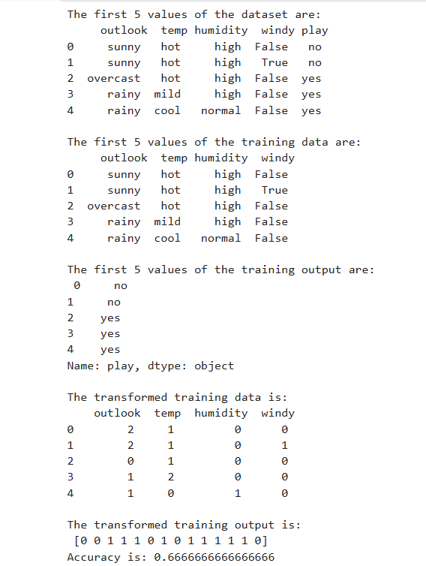
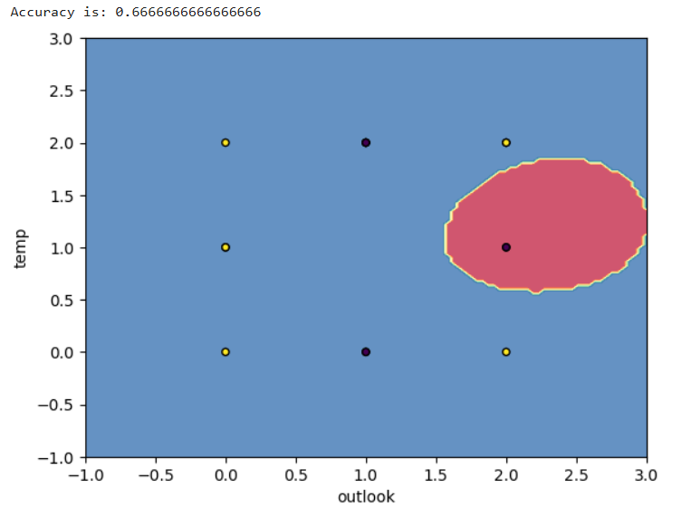

Apriori algorithm
Apriori Algorithm is a foundational method in data mining used for discovering frequent itemsets and generating association rules. Its significance lies in its ability to identify relationships between items in large datasets which is particularly valuable in market basket analysis.
For example, if a grocery store finds that customers who buy bread often also buy butter, it can use this information to optimise product placement or marketing strategies.

How the Apriori Algorithm Works?
The Apriori Algorithm operates through a systematic process that involves several key steps:
- Identifying Frequent Itemsets: The algorithm begins by scanning the dataset to identify individual items (1-item) and their frequencies. It then establishes a minimum support threshold, which determines whether an itemset is considered frequent.
- Creating Possible item group: Once frequent 1-itemgroup(single items) are identified, the algorithm generates candidate 2-itemgroup by combining frequent items. This process continues iteratively, forming larger itemsets (k-itemgroup) until no more frequent item group can be found.
- Removing Infrequent Item groups: The algorithm employs a pruning technique based on the Apriori Property, which states that if an item set is infrequent, all its supersets must also be infrequent. This significantly reduces the number of combinations that need to be evaluated.
- Generating Association Rules: After identifying frequent itemsets, the algorithm generates association rules that illustrate how items relate to one another, using metrics like support, confidence, and lift to evaluate the strength of these relationships.
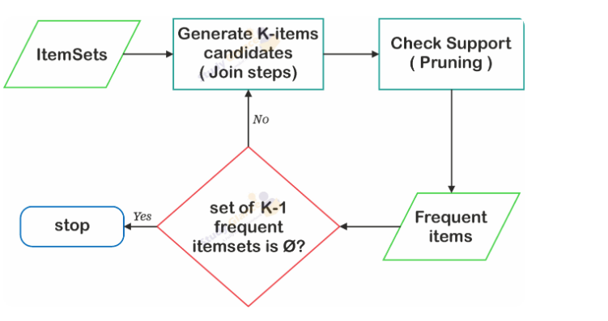
Figure 1 Steps in Apriori Algorithm

Key Metrics of Apriori Algorithm
- Support: This metric measures how frequently an item appears in the dataset relative to the total number of transactions. A higher support indicates a more significant presence of the itemset in the dataset. Support tells us how often a particular item or combination of items appears in all the transactions (“Bread is bought in 20% of all transactions.”)
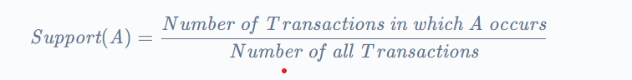
- Confidence: Confidence assesses the likelihood that an item Y is purchased when item X is purchased. It provides insight into the strength of the association between two items. Confidence tells us how often items go together. (“If bread is bought, butter is bought 75% of the time.”)
- 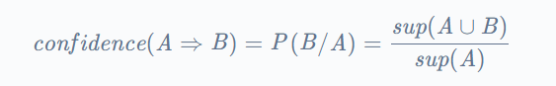
- Lift: Lift evaluates how much more likely two items are to be purchased together compared to being purchased independently. A lift greater than 1 suggests a strong positive association. Lift shows how strong the connection is between items. (“Bread and butter are much more likely to be bought together than by chance.”)

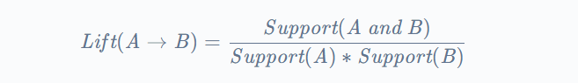

PROGRAM

import pandas as pd

from apyori import apriori

# Load dataset (ensure the file path is correct)

dataset = pd.read_csv('groceries_dataset.csv')

# Create a list of transactions

transactions = []

for i in range(len(dataset)):

transactions.append([str(dataset.values[i, j]) for j in range(dataset.shape[1])])

# Apply Apriori algorithm

rules = apriori(transactions, min_support=0.0003, min_confidence=0.05, min_lift=3, max_length=2)

# Convert rules to a list

association_results = list(rules)

# Check if there are any results

if len(association_results) > 0:

# Get the last (most frequent) rule

most_frequent_rule = association_results[-1]

# Extract items in the rule

items = [x for x in most_frequent_rule.items]

# Ensure the rule has two items (A -> B)

if len(items) == 2:

# Print the rule metrics

print(f"Rule: {items[0]} -> {items[1]}")

print(f"Support: {most_frequent_rule.support}")

print(f"Confidence: {most_frequent_rule.ordered_statistics[0].confidence}")

print(f"Lift: {most_frequent_rule.ordered_statistics[0].lift}")

else:

print("No valid two-item rule found.")

else:

print("No association rules generated.")

OUTPUT

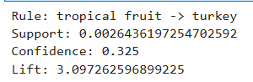
 | Experiment Title: Simulate Artificial Neural Network.
 | Laboratory: MACHINE LEARNING LAB
Experiment No: 9 | Department | Semester:

Artificial Neural Network
Artificial Neural Networks contain artificial neurons, which are called units. These units are arranged in a series of layers that together constitute the whole Artificial Neural Network in a system. A layer can have only a dozen units or millions of units, as this depends on how the complex neural networks will be required to learn the hidden patterns in the dataset. Commonly, an Artificial Neural Network has an input layer, an output layer, as well as hidden layers. The input layer receives data from the outside world, which the neural network needs to analyze or learn about. Then, this data passes through one or multiple hidden layers that transform the input into data that is valuable for the output layer. Finally, the output layer provides an output in the form of a response of the Artificial Neural Networks to the input data provided.
In the majority of neural networks, units are interconnected from one layer to another. Each of these connections has weights that determine the influence of one unit on another unit. As the data transfers from one unit to another, the neural network learns more and more about the data, which eventually results in an output from the output layer.
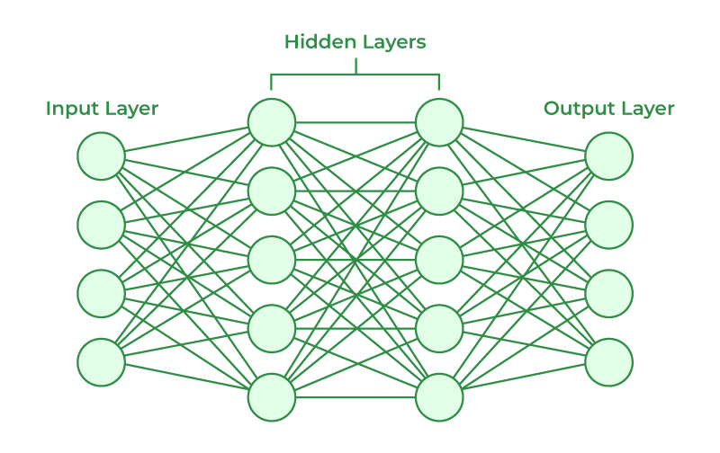
Figure 1 ANN
The structures and operations of human neurons serve as the basis for artificial neural networks. It is also known as neural networks or neural nets. The input layer of an artificial neural network is the first layer, and it receives input from external sources and releases it to the hidden layer, which is the second layer. In the hidden layer, each neuron receives input from the previous layer neurons, computes the weighted sum, and sends it to the neurons in the next layer. These connections are weighted means effects of the inputs from the previous layer are optimized more or less by assigning different-different weights to each input and it is adjusted during the training process by optimizing these weights for improved model performance.

Artificial neurons vs Biological neurons
The concept of artificial neural networks comes from biological neurons found in animal brains So they share a lot of similarities in structure and function wise.
- Structure: The structure of artificial neural networks is inspired by biological neurons. A biological neuron has a cell body or soma to process the impulses, dendrites to receive them, and an axon that transfers them to other neurons. The input nodes of artificial neural networks receive input signals, the hidden layer nodes compute these input signals, and the output layer nodes compute the final output by processing the hidden layer’s results using activation functions
- Synapses: Synapses are the links between biological neurons that enable the transmission of impulses from dendrites to the cell body. Synapses are the weights that join the one-layer nodes to the next-layer nodes in artificial neurons. The strength of the links is determined by the weight value.
- Learning: In biological neurons, learning happens in the cell body nucleus or soma, which has a nucleus that helps to process the impulses. An action potential is produced and travels through the axons if the impulses are powerful enough to reach the threshold. This becomes possible by synaptic plasticity, which represents the ability of synapses to become stronger or weaker over time in reaction to changes in their activity. In artificial neural networks, backpropagation is a technique used for learning, which adjusts the weights between nodes according to the error or differences between predicted and actual outcomes.

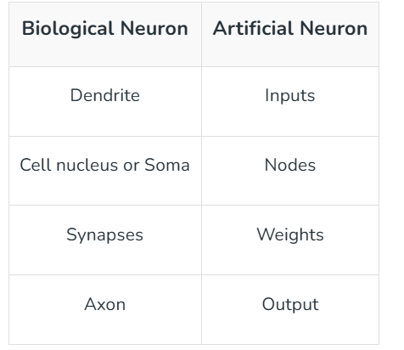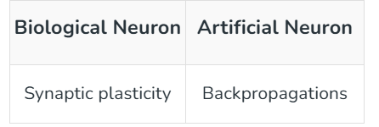

Figure 2 Artificial neurons vs Biological neurons

- Activation: In biological neurons, activation is the firing rate of the neuron which happens when the impulses are strong enough to reach the threshold. In artificial neural networks, A mathematical function known as an activation function maps the input to the output, and executes activations.
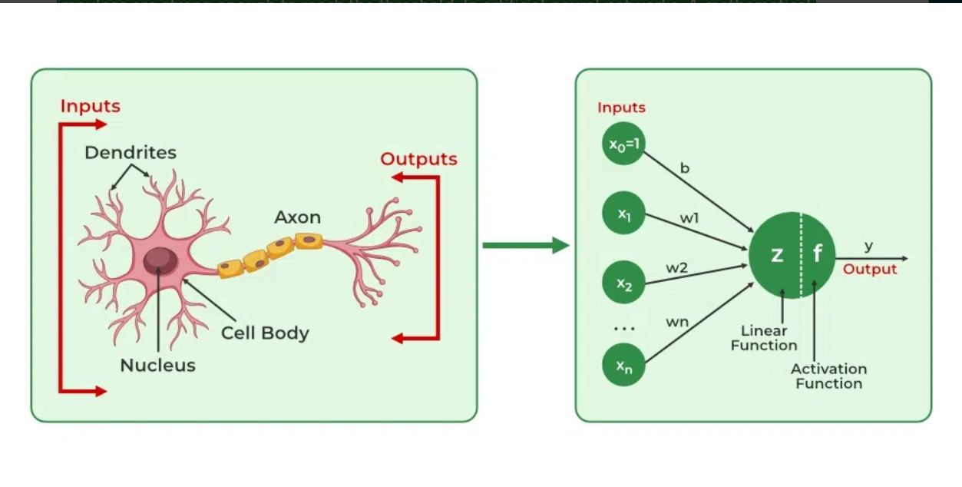
Figure 3 Biological neurons to Artificial neurons

How do Artificial Neural Networks learn?
Artificial neural networks are trained using a training set. For example, suppose you want to teach an ANN to recognize a cat. Then it is shown thousands of different images of cats so that the network can learn to identify a cat. Once the neural network has been trained enough using images of cats, then you need to check if it can identify cat images correctly. This is done by making the ANN classify the images it is provided by deciding whether they are cat images or not. The output obtained by the ANN is corroborated by a human-provided description of whether the image is a cat image or not. If the ANN identifies incorrectly then is used to adjust whatever it has learned during training. Backpropagation is done by fine-tuning the weights of the connections in ANN units based on the error rate obtained. This process continues until the artificial neural network can correctly recognize a cat in an image with minimal possible error rates.

In Computer Science, we model this process by creating “networks” on a computer using matrices. These networks can be understood as an abstraction of neurons without all the biological complexities taken into account. To keep things simple, we will just model a simple NN, with two layers capable of solving a linear classificationproblem.
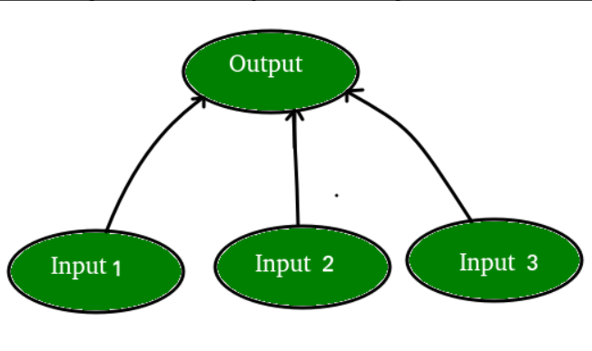
Figure 4
Let’s say we have a problem where we want to predict output given a set of inputs and outputs as training example like so:
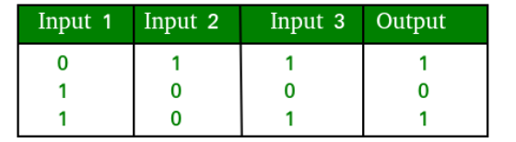
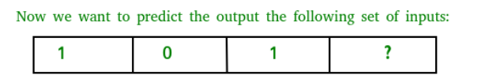
Figure 5
Note that the output is directly related to the third column i.e. the values of input 3 is what the output is in every training example in fig. 2. So for the test example output value should be 1.

PROGRAM
import numpy as np
# Sigmoid activation function
def sigmoid(x):
return 1 / (1 + np.exp(-x))

# Derivative of sigmoid
def sigmoid_derivative(x):
return x * (1 - x)

# Initialize input data and expected output
inputs = np.array([[0, 0],
[0, 1],
[1, 0],
[1, 1]])
expected_output = np.array([[0], [1], [1], [0]])

# Initialize weights randomly
np.random.seed(0)
weights = np.random.rand(2, 1)
bias = np.random.rand(1)
learning_rate = 0.1

# Training the network
for epoch in range(10000):
# Forward propagation
weighted_sum = np.dot(inputs, weights) + bias
activated_output = sigmoid(weighted_sum)

# Backpropagation
error = expected_output - activated_output
adjustments = error * sigmoid_derivative(activated_output)
weights += np.dot(inputs.T, adjustments) * learning_rate
bias += np.sum(adjustments) * learning_rate

# Testing the network
print("Trained weights:", weights)
print("Trained bias:", bias)
print("Output after training:")
print(sigmoid(np.dot(inputs, weights) + bias))

OUTPUT
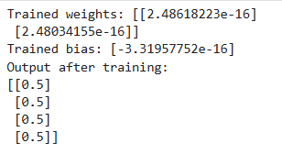

 | Experiment Title: Implement the Genetic Algorithm code.
 | Laboratory: MACHINE LEARNING LAB
Experiment No: 10 | Department | Semester:

Genetic Algorithms
Genetic Algorithms(GAs) are adaptive heuristic search algorithms that belong to the larger part of evolutionary algorithms. Genetic algorithms are based on the ideas of natural selection and genetics. These are intelligent exploitation of random searches provided with historical data to direct the search into the region of better performance in solution space. They are commonly used to generate high-quality solutions for optimization problems and search problems.
Genetic algorithms simulate the process of natural selection which means those species that can adapt to changes in their environment can survive and reproduce and go to the next generation. In simple words, they simulate “survival of the fittest” among individuals of consecutive generations to solve a problem. Each generation consists of a population of individuals and each individual represents a point in search space and possible solution. Each individual is represented as a string of character/integer/float/bits. This string is analogous to the Chromosome.

Algorithm:
- Population: Begin with a group of random solutions to the problem.
- Fitness Function: Evaluate how good each solution is using a fitness function, which measures how well it solves the problem.
- Selection: Choose the best solutions from the population to become parents for the next generation.
- Crossover: Combine pairs of parents to create new solutions (offspring).
- Mutation: Occasionally introduce random changes to keep the solutions diverse.
- Repeat: Continue this process for many generations, gradually improving the solutions.

Operators of Genetic Algorithms
Once the initial generation is created, the algorithm evolves the generation using following operators –
Selection operator: The idea is to give preference to the individuals with good fitness scores and allow them to pass their genes to successive generation.
Crossover Operator: This represents mating between individuals. Two individuals are selected using selection operator and crossover sites are chosen randomly. Then the genes at these crossover sites are exchanged thus creating a completely new individual (offspring). For example –
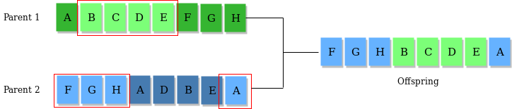
Figure 1
Mutation Operator: The key idea is to insert random genes in offspring to maintain the diversity in the population to avoid premature convergence. For example –
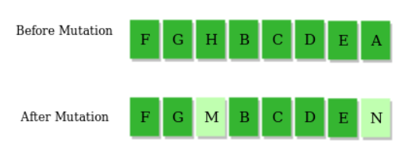
Figure 7

Example problem and solution using Genetic Algorithms
Given a target string, the goal is to produce target string starting from a random string of the same length. In the following implementation, following analogies are made –
- Characters A-Z, a-z, 0-9, and other special symbols are considered as genes
- A string generated by these characters is considered as chromosome/solution/Individual
Fitness score is the number of characters which differ from characters in target string at a particular index. So individual having lower fitness value is given more preference.

PROGRAM
#import libraries
import random

# Define the fitness function
def fitness_function(individual):
return sum(individual)

# Create an initial population
def create_population(size, chromosome_length):
return [[random.randint(0, 1) for _ in range(chromosome_length)] for _ in range(size)]

# Select parents for crossover
def select_parents(population, fitnesses):
total_fitness = sum(fitnesses)
selection_probs = [fitness / total_fitness for fitness in fitnesses]
parents = random.choices(population, weights=selection_probs, k=2)
return parents

# Perform crossover between two parents
def crossover(parent1, parent2):
crossover_point = random.randint(1, len(parent1) - 1)
child1 = parent1[:crossover_point] + parent2[crossover_point:]
child2 = parent2[:crossover_point] + parent1[crossover_point:]
return child1, child2

# Mutate an individual
def mutate(individual, mutation_rate):
for i in range(len(individual)):
if random.random() < mutation_rate:
individual[i] = 1 if individual[i] == 0 else 0

# Genetic Algorithm
def genetic_algorithm(population_size, chromosome_length, generations, mutation_rate):
population = create_population(population_size, chromosome_length)
for generation in range(generations):
fitnesses = [fitness_function(individual) for individual in population]
new_population = []
for _ in range(population_size // 2):
parent1, parent2 = select_parents(population, fitnesses)
child1, child2 = crossover(parent1, parent2)
mutate(child1, mutation_rate)
mutate(child2, mutation_rate)
new_population.extend([child1, child2])
population = new_population
best_fitness = max(fitnesses)
print(f"Generation {generation}: Best Fitness = {best_fitness}")
best_individual = max(population, key=fitness_function)
return best_individual

# Parameters
population_size = 10
chromosome_length = 8
generations = 20
mutation_rate = 0.01

# Run the Genetic Algorithm
best_solution = genetic_algorithm(population_size, chromosome_length, generations, mutation_rate)
print("Best Solution:", best_solution)
print("Best Solution Fitness:", fitness_function(best_solution))

OUTPUT
